**SREE NARAYANA COLLEGE ALATHUR**

Affiliated to the University of Calicut

**DEPARTMENT OF MICROBIOLOGY**

**Biodiversity – Beauty and Science**

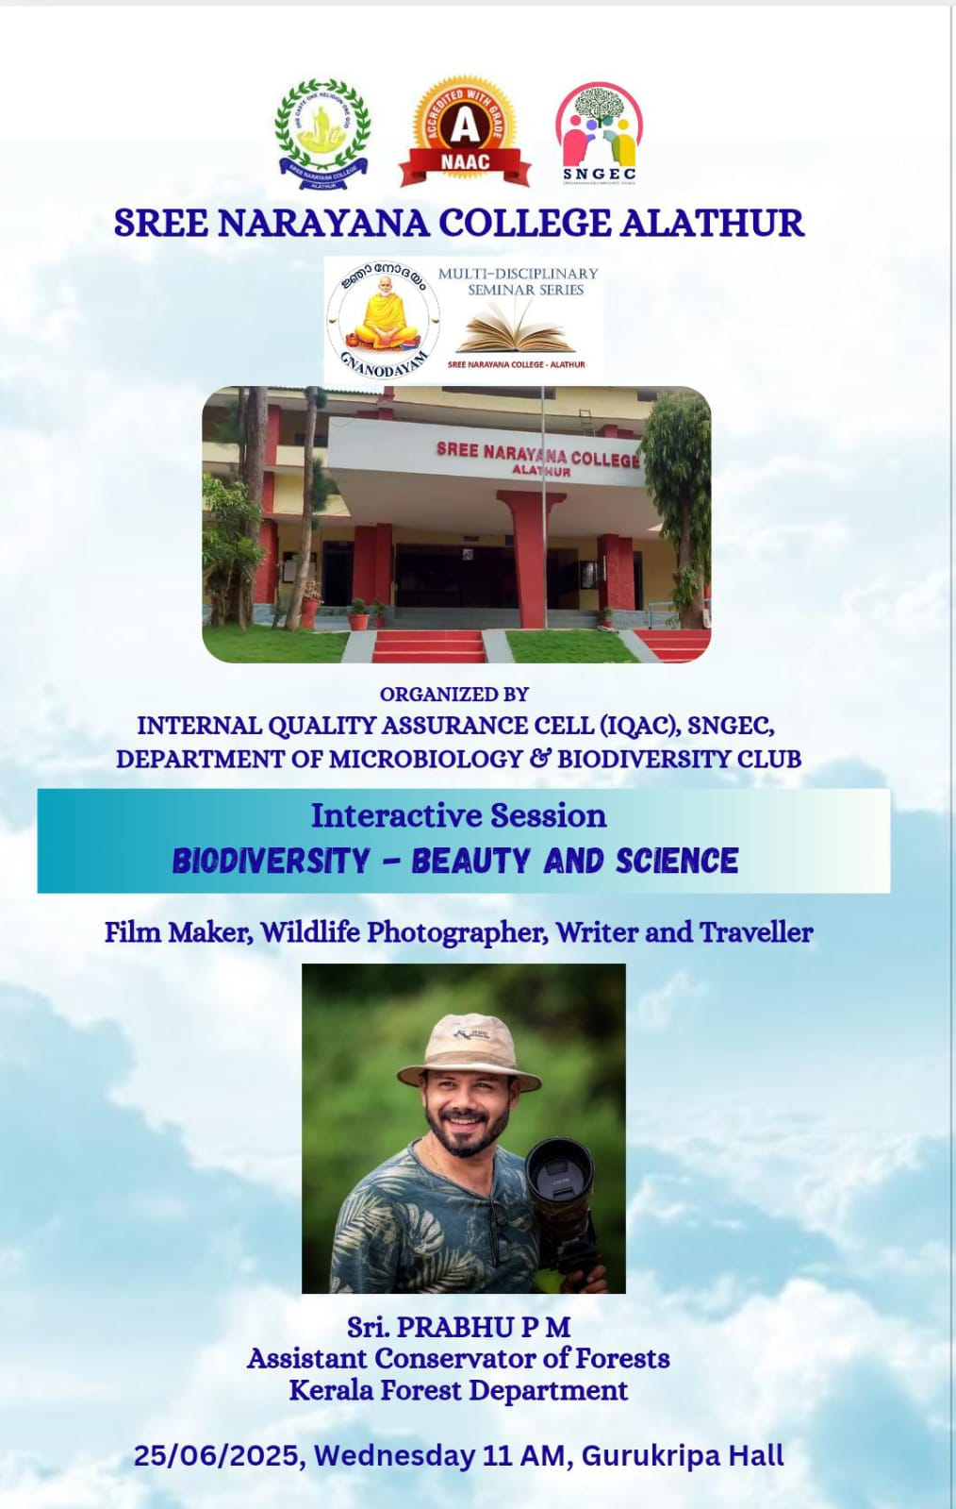

An enlightening interactive session titled “Biodiversity – Beauty and Science” was conducted on 25th June 2025 at Gurukripa Hall, organized by the Department of Microbiology, Sree Narayana Guru Employees’ Council, and the Biodiversity Club, in association with the Internal Quality Assurance Cell (IQAC) of Sree Narayana College, Alathur.

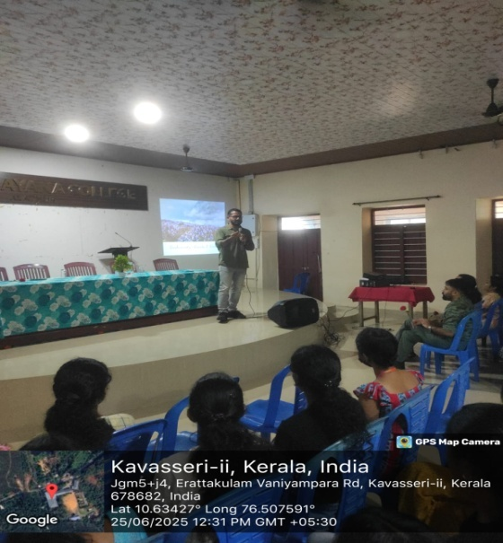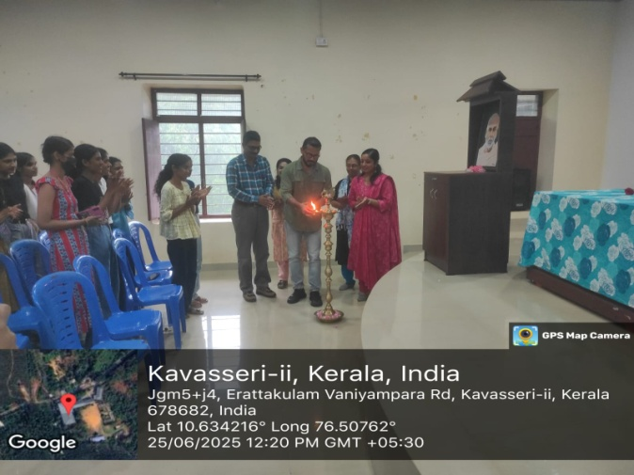

The session was graced by Sri. Prabhu P. M., Assistant Conservator of Forests, Kerala Forest Department, as the resource person. With his vast experience in forest conservation and environmental protection, Sri. Prabhu delivered an engaging and thought-provoking presentation that captivated the audience comprising students, faculty members, and environmental enthusiasts.

In his address, Sri. Prabhu emphasized the intrinsic beauty of biodiversity and its scientific significance in sustaining ecosystems. He highlighted the urgent need for biodiversity conservation in the face of climate change, habitat destruction, and human intervention. Drawing from real-life experiences from his service in the forest department, he offered deep insights into the challenges and successes in biodiversity preservation efforts in Kerala and beyond.

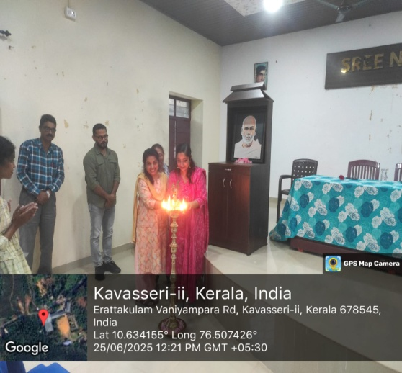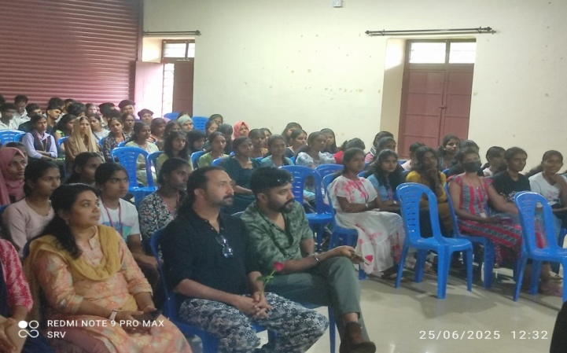

The session was highly interactive, with active participation from students who posed insightful questions and shared their perspectives. The discussions fostered awareness about the role of youth and academic institutions in promoting environmental stewardship.

The program began with a welcome address by Smt Divya R, Assistant Professor, Department of Microbiology, followed by an inaugural address by Dr M Binumol , Coordinator of Biodiversity Club. Dr Shabna Babu, Assistant Professor,Department of Commerce felicitated the guest speaker and students.The event concluded with a vote of thanks by Dr Sumesh RV, State Secretary ,SNGEC.

Overall, the session was a resounding success, igniting a renewed sense of commitment among the attendees toward the conservation of biodiversity and appreciation of nature’s intricate beauty through the lens of science.